Firstly what we asked was
- Digital health records (longitudinal patient history)
- Lab + pharmacy integration
- Referral system (GP → specialist)
- LMS + patient education
- Clinical audit + QA
- Gamification & lifestyle tracking
But what you gave is very basic focuses mainly on:
- booking
- video consult
- basic prescription
That’s only 30–40% of your vision
We clearly asked for advanced ecosystem requirements like:
- “Quality assurance parameters / Clinical Audit”
- “Doctors LMS / Patient educational”
- “Discussion forums”
- “Gamification & analytics”
A real virtual hospital must include:
- Structured consultation flow (history → exam → diagnosis → plan)
- Referral pathways
- Clinical documentation standards
We required:
- Clinical audit
- Revenue analytics
- System usage reports
- QA monitoring
And you gave us give:
❌ simple dashboards
❌ no real healthcare analytics
And what about:
- Subscription plans
- Tiered services
- Chronic care programs
- Preventive health packages
Where these will go?
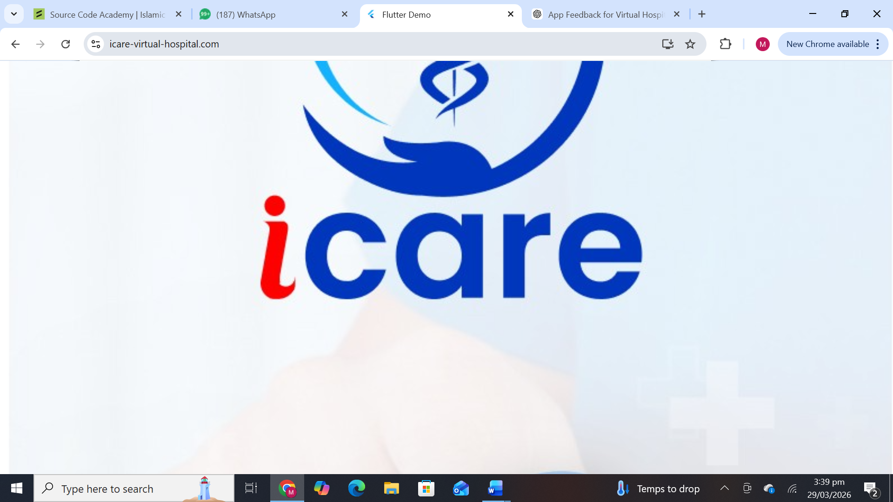
WHEN WE OPEN WEBSITE ICARE LOGOAPPEARS ZOOME OUT
“The login screen needs to establish trust and clearly communicate that this is a healthcare platform. Currently, it feels like a generic system interface. Please add healthcare-specific messaging, such as a tagline and trust indicators (secure data, verified doctors).
The ‘Switch Role / Testing Bypass’ option should be removed from the user interface and handled internally or during signup. Role selection should be user-friendly and invisible during login.
Additionally, improve visual balance by reducing logo size and adding meaningful content such as key platform benefits. Enhance emotional design by using healthcare-relevant visuals and softer, reassuring design elements.
Finally, include better microcopy and guidance for users during login and error handling.”

1= Add under logo:
“Your Virtual Healthcare Platform”
“Secure consultations, prescriptions & health records”
Also add:
- “Secure & HIPAA-compliant” (or at least “Data Protected”)
- “Verified Doctors”
2.You wrote: “Switch Role / Testing Bypass” Replace with:
During signup:
- “I am a Patient”
- “I am a Doctor”
After login:
- System automatically routes
No “role switching” visible publicly
3. VISUAL BALANCE ISSUE, Left side too heavy (huge logo) while Right side form looks compressed ,please Reduce logo size and Add meaningful content on left:
LEFT SIDE:
- Logo
- Tagline
- 3 benefits: (optional)
  - Book doctors online
  - Get prescriptions
  - Access lab reports
4. WEAK EMOTIONAL CONNECTION: it Feels like generic software login , Add:
- Soft background (doctor/patient interaction)
- Or subtle healthcare illustration
5. Under login button:
  - “Access your health dashboard securely”
6. SOCIAL LOGIN: Google / Facebook shown without context please Add label: “Quick Sign In”
7. NO ERROR: You must ensure:
When user:
- enters wrong password
- forgets email
System should:
- clearly guide
- not frustrate
we want user friendly ideal login experience like
User opens app → Immediately understands:
- This is a healthcare system
- It is safe
- It is easy
LOGIN ROLE SCREEN :
“The role selection screen needs simplification and better alignment with user experience. Currently, too many roles are presented, which can confuse users and reduce engagement. Only ‘Patient’ and ‘Doctor’ should be visible at the initial stage, while other roles (lab technician, pharmacist, instructor, student) should be managed internally or through admin workflows.
The messaging under each role should be more benefit-driven and clearly explain what the user can do within the platform. Additionally, the UI should guide users by highlighting the primary role (Patient) and improving visual hierarchy.
The statement ‘Account type cannot be changed later’ creates unnecessary friction and should be removed or softened.
Finally, this screen should only appear during onboarding for new users, not for returning users, and should clearly communicate trust, security, and healthcare relevance.”
REMEMBER THIS : Not all users are equal and Not all users should enter the system the same way our login screen should feel like “I’m entering a hospital system” NOT “I’m logging into software”
Split roles into 2 layers:
Step 1 (Public-facing):
Show ONLY:
- Patient
- Doctor
Step 2 (Inside system / admin-controlled):
- Lab Technician
- Pharmacist
- Instructor
- Student
These should NOT be shown to general users
- Make it benefit-driven + specific
Example:
Patient:
👉 “Consult doctors, access prescriptions & manage your health”
Doctor:
👉 “Manage patients, consultations & digital prescriptions”
NO TRUST BUILDING
For healthcare, first screen must say:
👉 “You are safe here”
Add:
- 🔒 Secure platform
- ✔ Verified professionals
- 📊 Trusted healthcare system
“ACCOUNT TYPE CANNOT BE CHANGED” Change to: “Your role helps personalize your experience” OR remove completely and CONTINUE BUTTON remove with“Select a role to continue”
- Right now Feels like system selection while should feel like “Welcome to your healthcare journey”
IDEAL FLOW
Current Flow:
Login → Role selection → Dashboard
While it should be something like this :
- First-time user only Select role while Returning user Skip this screen completely

Example:
- If Patient selected:
→ Health dashboard
→ Consult doctor
→ LMS = “Health Programs”
- If Doctor selected:
- → Clinical dashboard
→ Patient management
→ LMS = “Professional training”
- SAME SYSTEM
- DIFFERENT EXPERIENCE
OUR SYSTEM HAS 2 TYPES OF USERS
1. PUBLIC USERS (Self-signup)
These are people who come to your platform directly:
- Patient
- Doctor (optional self-apply)
These should:
- Sign up themselves
- Choose role
- Enter system directly but require approval
2. CONTROLLED USERS (Admin-managed)
These are system partners, NOT random users:
- Lab Technician
- Pharmacy
- Instructor (LMS teachers)
- students
These should NOT freely sign up
CORRECT SYSTEM DESIGN (VERY IMPORTANT)
ADMIN CREATES THESE USERS
For Labs:
Admin:
- Registers lab
- Adds:
  - Name
  - Location
  - License
  - Contact
Then system generates:
- Login ID
- Password
For Pharmacy:
Same process:
- Verified onboarding
- Admin approval
For Instructor and student same
LOGIN FLOW FOR THEM
They DO NOT go through “Patient/Doctor selection”
Instead:
Same login page
System detects role automatically
HOW THEY USE SYSTEM
LAB FLOW
- Receives test request from doctor
- Accepts/rejects
- Uploads report
- Sends to patient
PHARMACY FLOW
- Receives prescription
- Confirms availability
- Manages delivery
- Updates status
INSTRUCTOR FLOW
- Creates courses
- Assigns to patients/doctors
- Tracks progress
HOW THIS CONNECTS TO PATIENT
Example:
1. Doctor prescribes:
- Lab test
- Medicine
- Learning program
2. System automatically sends:
- Lab request → Lab dashboard
- Prescription → Pharmacy
- Course → LMS
3. Patient sees everything in ONE place:
- My Tests
- My Medicines
- My Learning
This is what we have been asking
“Roles such as Lab Technician, Pharmacy, and Instructor should not be available for public signup. These roles must be created and managed through the admin panel with proper verification and onboarding processes.
The system should support role-based access where users log in through a single interface, and the system automatically routes them to their respective dashboards based on assigned roles.
Patients and doctors can register through the application, but labs, pharmacies, and instructors must be controlled entities to ensure system reliability, quality, and compliance.”
Think of our system like a real hospital:
- Patients walk in
- Doctors apply / are approved
- Labs & pharmacy are authorized partners

ROLE AS STUDENT :
“The LMS should not function as a standalone academic module. It must be integrated into the clinical workflow. Patients should see it as ‘Health Programs’ or ‘Care Plans’ assigned by doctors, not generic courses. The interface must be role-based, showing different experiences for patients and professionals. Additionally, courses should be linked to diagnoses, prescriptions, and follow-ups to ensure continuity of care.”

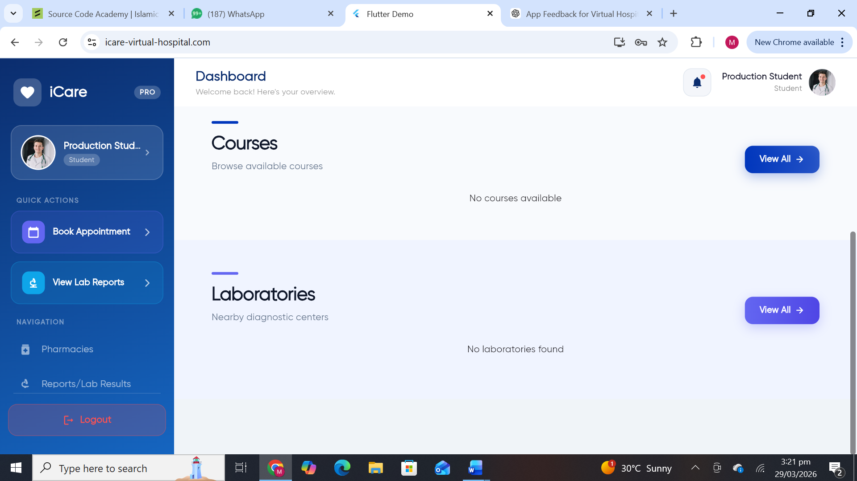
Figure 1Y LABORTARIES IN LMS? Y NAVIGATION SHOWING LABS PHARMACIES AND EXTRA IN LMS
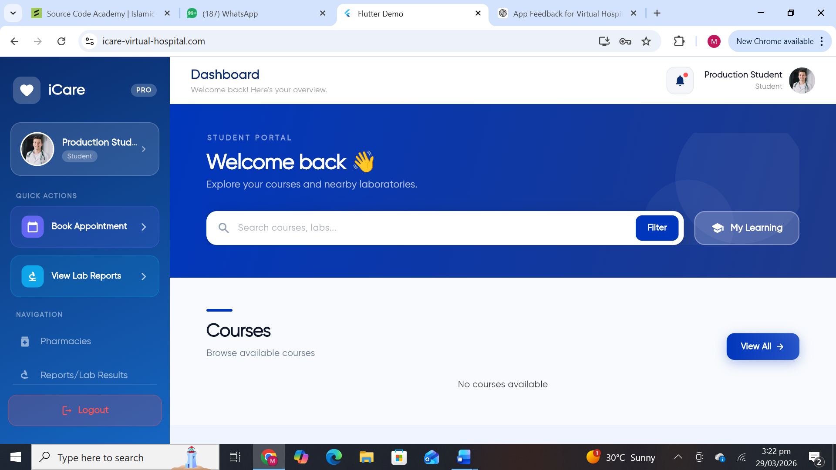
Figure 2 Y DASHBOARD MENTION LABORATRIES NEARBY UNDERWELCOME AS ITS LMS?
1. DASHBOARD (Student View)
Even if LMS is valid, Why does a patient see “Student Portal”?
This creates:
- Identity confusion
- Trust issues
- Cognitive overload
we need ROLE-BASED EXPERIENCE
✔ If user = Patient:
- Hide LMS language
- Show:
  - “Health Programs”
  - “Your Care Plan”
✔ If user = Doctor / Student:
- Show LMS (courses, certificates)
- SAME SYSTEM
- DIFFERENT UX
2. COURSES PAGE → Rename & Reposition
Current:
- “Find your next course”
- Academic tone
Change to:
For Patients:
“Health Programs”
Examples:
- Diabetes Management Program
- Weight Loss Plan
- Prenatal Care
For Doctors:
Keep:
- Courses
- Certifications
3. MY LEARNING → TRANSFORM
Current:
- Empty courses
- Certificates
For Patients:
Rename to:
“My Health Journey”
Show:
- Assigned programs
- Progress
- Doctor recommendations
For Professionals:
Keep:
- My Courses
- Certificates
Integration Model
1. Doctor → LMS Connection
During consultation:
Doctor should be able to:
- Assign course/program to patient
Example:
- “Hypertension Control Program”
- “Post-surgery rehabilitation”
2. Patient Dashboard Integration
After consultation:
Automatically show:
- “Your Care Plan”
- “Recommended Learning”
3. Smart Linking
Inside LMS:
Every course should connect to:
- Condition
- Treatment plan
- Follow-up
REAL USER FLOW
- Patient books consultation
→ Doctor diagnoses diabetes
→ System (DOCTOR) does:
- Adds medication
- Recommends lab tests
- Assigns “Diabetes Care Program”
- Schedules follow-up
- Patient sees:
- My Medications
- My Reports
- My Learning
Right now LMS Feels like Separate app It should feel likePart of treatment/app NOT “extra feature”
When doctor prescribes:
Instead of only:
- Medicine
Add:
- Medicine
- Lab
- Learning module
LOGGED INTO INSTRUCTOR ACCOUNT THIS HAPPENED
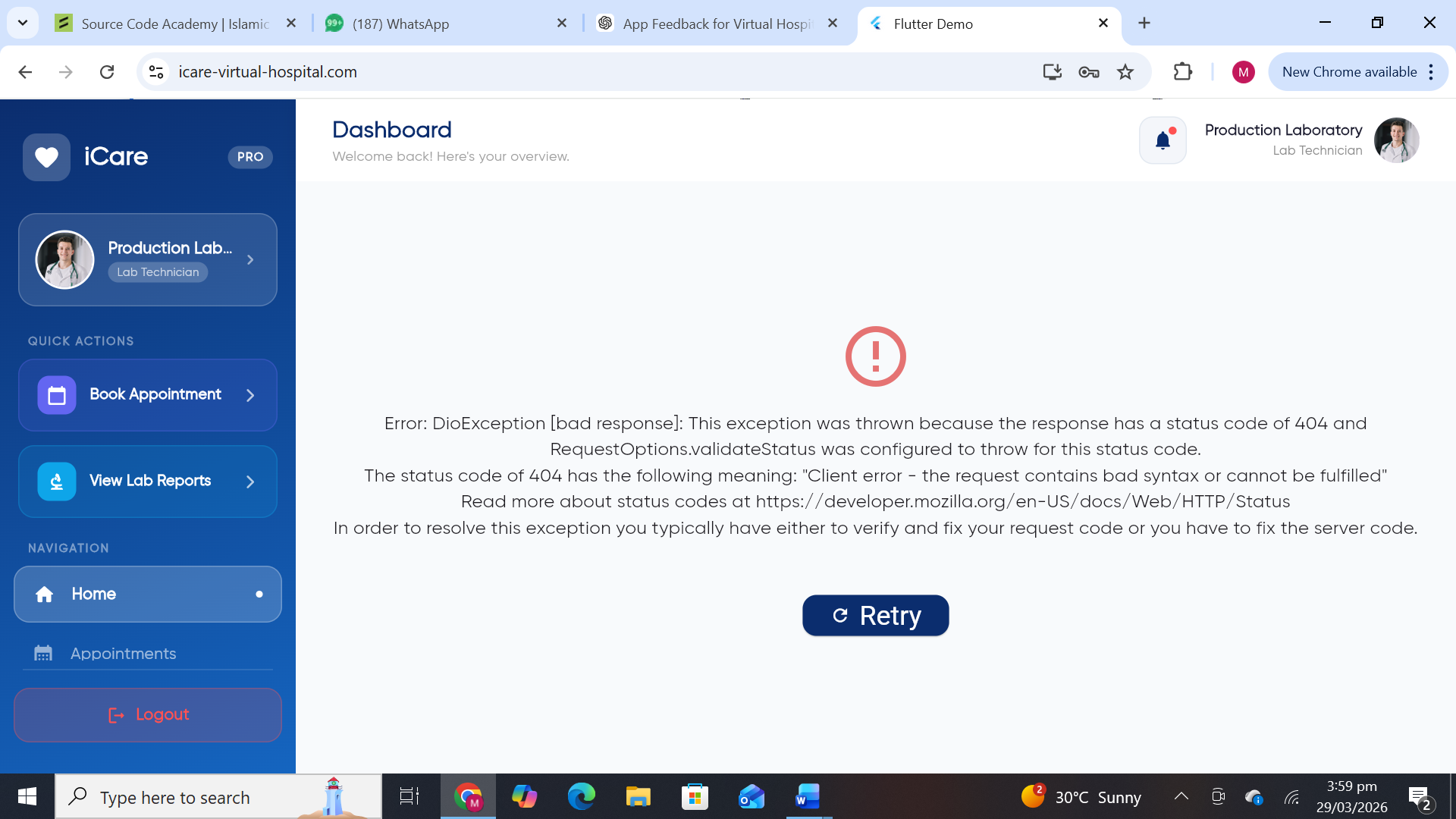
Y EVERY DASHBOARD ROLE IS SAME? Y BOOK APPOINTMENT
LAB DASHBOARD
1. CRITICAL ERROR You’re showing:
DioException / 404 / developer message
What it SHOULD show instead:
Clean error state:
- “Unable to load test requests right now”
- “Please try again”
Buttons:
- Retry
- Contact support
“Never expose backend errors to end users”
2. WRONG DASHBOARD STRUCTURE
Current:
- Book Appointment
- View Lab Reports
Lab users don’t:
- book appointments
- browse reports
They PROCESS requests
CORRECT LAB DASHBOARD
Lab Role = “Service Provider”
They should:
- Receive test requests
- Process tests
- Upload reports
our dashboard MUST show:
TOP SECTION:
- Pending Requests
- In Progress
- Completed
MAIN TABLE:
Each request should show:
- Patient Name
- Doctor Name
- Test Type
- Date
- Status
- Action button
ACTION BUTTONS:
- Accept Request
- Mark as Completed
- Upload Report
3. MISSING CORE FEATURE
There is NO visible:
- Incoming requests
- Workflow
- Actions
We NEED:
“Incoming Test Requests” module
HOW LAB CONNECTS TO OUR SYSTEM
This is the heart of your virtual hospital
Real Workflow:
Step 1: Doctor: Orders lab test
Step 2: System: Sends request to Lab dashboard
Step 3: Lab:
- Accepts request
- Performs test
- Uploads report
Step 4: Patient: Sees report instantly
THIS is what our system must do
4. SIDEBAR UX IS WRONG
Replace with:
For LAB:
- Dashboard
- Test Requests
- Upload Reports
- History
- Profile
5. NO PRIORITY / URGENCY HANDLING
In healthcare: Not all tests are equal
Add:
- Urgent cases (highlighted)
- Normal cases
- Completed
6. NO PATIENT CONTEXT
Lab must know:
- Who is patient
- Who is doctor
- Why test is ordered
Add:
- Diagnosis note
- Doctor instructions
“The current lab dashboard is not aligned with the actual workflow required for lab users and appears to be a reused patient interface. Critical functionality such as incoming test requests, status management, and report uploads is missing.
Additionally, the system is currently displaying raw technical error messages (e.g., DioException 404), which is not acceptable for end users and must be replaced with user-friendly error handling.
The lab interface should be redesigned to focus on its core workflow: receiving test requests from doctors, processing those requests, uploading reports, and tracking status.
The navigation menu should also be role-specific, replacing irrelevant options such as ‘Book Appointment’ with ‘Test Requests,’ ‘Upload Reports,’ and ‘History.’
This module is a core part of the virtual hospital system and must be designed as a functional service workflow, not as a static dashboard.”
Right now our system Looks like multiple disconnected apps we need ONE SYSTEM with
DIFFERENT ROLE EXPERIENCES
ROLE AS PHARMACY
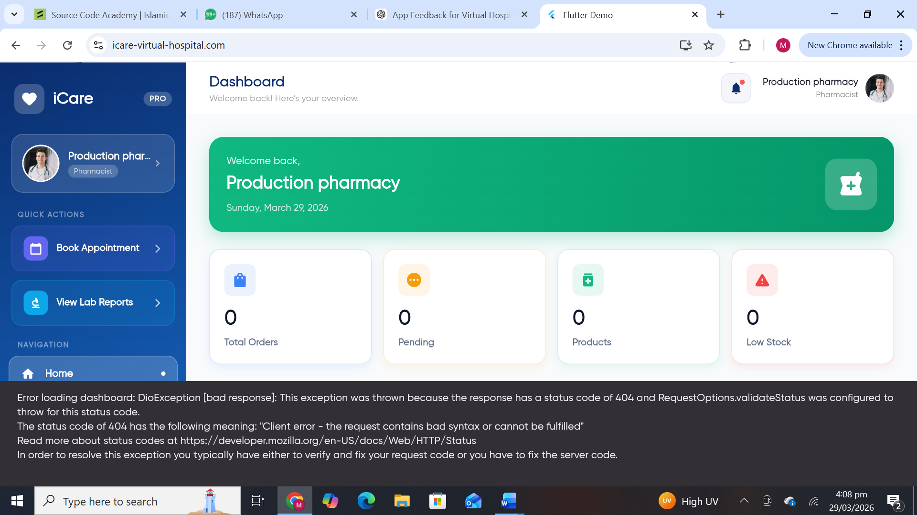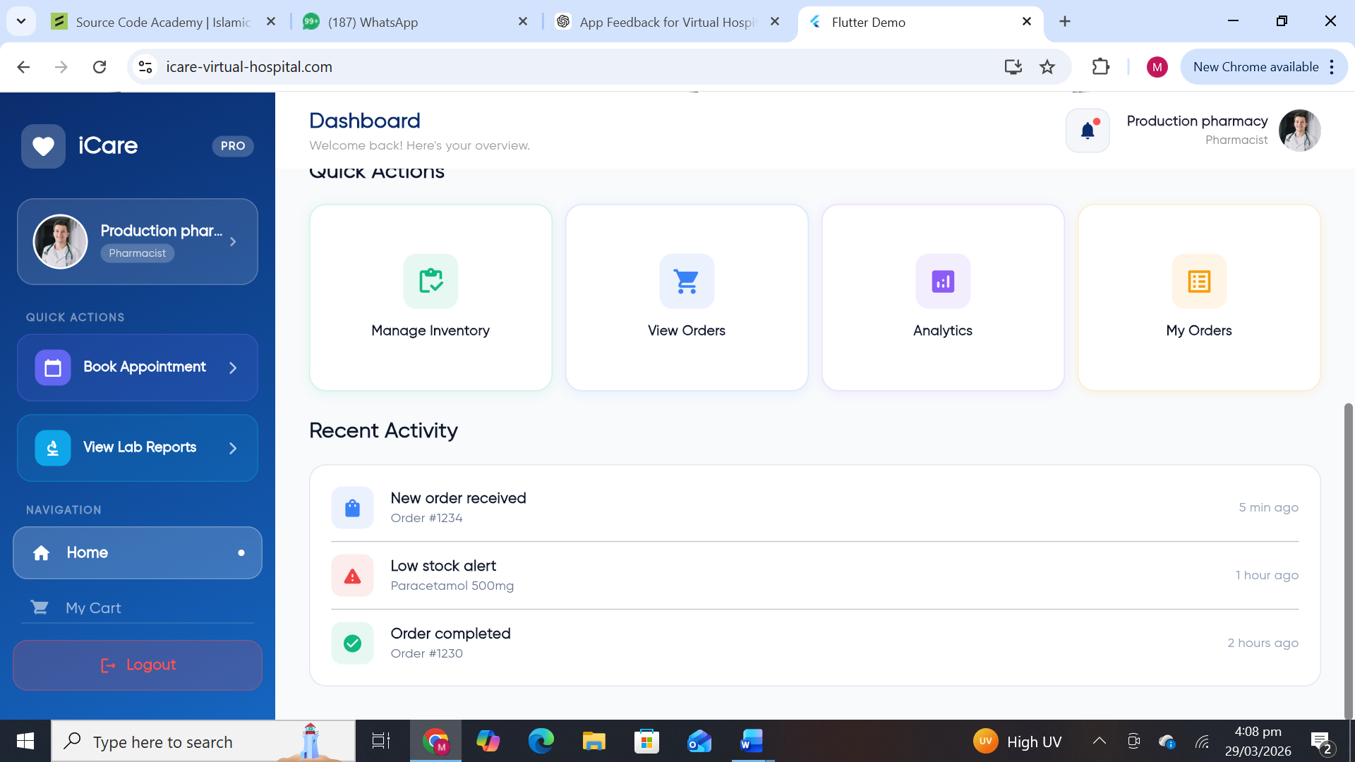
This screen MUST be Pharmacy Partner Dashboard (B2B side) NOT patient-facing
1. DASHBOARD
Issues:
- “Book Appointment” → irrelevant
- “View Lab Reports” → irrelevant
- “My Cart” → patient feature
- “Inventory + Orders” → pharmacy feature
This is a mixed UI
2. ERROR MESSAGES
3. INVENTORY SCREEN
- Categories (Pain Relief, Antibiotics etc.)
- Search bar
- “Add Product” button
- Sample placeholder
- Bulk upload option
4. ORDERS SCREEN
Should show:
Each order:
- Patient name
- Prescription
- Medicines
- Status
Buttons:
- Accept
- Reject
- Mark as delivered
5. ANALYTICS SCREEN
Should show:
- Orders per day
- Revenue
- Top medicines
6. “MY CART” Pharmacy should NOT have cart
our system is built as Feature-based, UI reused across roles. It NEEDS to be Role-based and Workflow-driven
CORRECT PHARMACY SYSTEM
Pharmacy Role = “Order Fulfillment System”
NOT shopping
NOT browsing
IDEAL PHARMACY DASHBOARD
TOP:
- New Orders
- Pending
- Completed
- Low Stock
MAIN SECTION:
“Incoming Prescriptions”
Each row:
- Patient
- Doctor
- Medicine list
- Status
ACTIONS:
- Accept Order
- Prepare Medicines
- Dispatch
- Mark Delivered
HOW IT CONNECTS TO OUR SYSTEM
REAL FLOW:
Step 1: Doctor: Prescribes medicine
Step 2: System: Sends prescription to patient, patient have 2 choices either to buy himself or send to pharmacy through system
Step 3: Pharmacy:
- Accepts
- Prepares
- Ships
Step 4: Patient: Receives medicine
“The pharmacy module currently shows a mix of patient and pharmacy functionalities, which creates confusion in user experience and system logic. Features such as ‘Book Appointment’ and ‘My Cart’ are not relevant to pharmacy users and should be removed.
The pharmacy interface must be redesigned as a fulfillment system where pharmacies receive prescriptions from doctors, process orders, and manage deliveries.
Additionally, the system is currently exposing backend error messages (e.g., DioException 404/403), which is unacceptable for end users and must be replaced with user-friendly error handling.
The dashboard should focus on incoming prescriptions, order status (pending, processing, completed), and inventory management. Each order should include patient details, prescribed medicines, and actionable steps such as accept, dispatch, and complete.
This module is a critical part of the virtual hospital ecosystem and must reflect a clear, role-specific workflow rather than a generic dashboard.”
We need A connected healthcare ecosystem

Areas lefts .
  - Secure login , to detect robots or fake traffic, finger print or face scanner security feature or login option. Terms and conditions agree on sign up process.
  - Easy login by Facebook or google. Or phone. Number
  - Email verification of users by clicking on link afterwards
  - Two factor account verification and sign in for security, it should be enabled in settings, people should have the options to change phone number email address, mailing addressed
  - User/ patient should be signed in after signing in. password save and remember me options for easy login
  - Webpage should look like a website with added features as mentioned above.
  - App UX is not aligned with phone screen.
  - Many functionalities are not tested yet due to errors in flow, fix these then we will be able to comment.
  - Make at least 10 users of each category and run their functionality. For examples, 10 doctors on boarded, 5 are specialists in different category, 5 are general, 10 pharmacies across Pakistan, 10 labs across Pakistan. 10 courses for doctor, 10 course/plans for patients, 10 patients from different regions of Pakistan. Then we will test functionality across different modules. They should interact as we explained earlier, complete integration of system from onboarding to payment, QA and analytics.
  - Please show admin, super admin and security related features. we need a demo on these portals to see what is included in these panels.
  - APPLICATION SHOULD WORK STAND ALONE AS DISCUSSED
  - ,Voice API, Language change ,Gamification and life style module is completely left presently.

